Polar Diameter
# Source: AI Source: Provided by: [Data Path: Persons Table -> ID Column: 1, Name_En Column: Motasem Essam] -> From: [ChatGPT] on [7/25/2026]
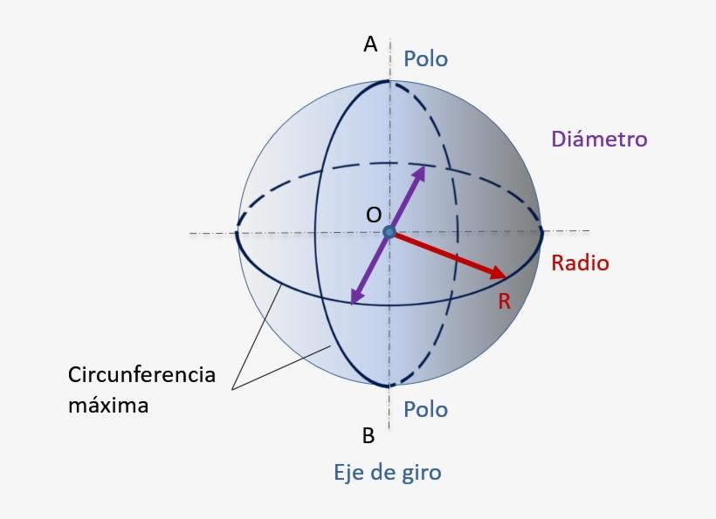
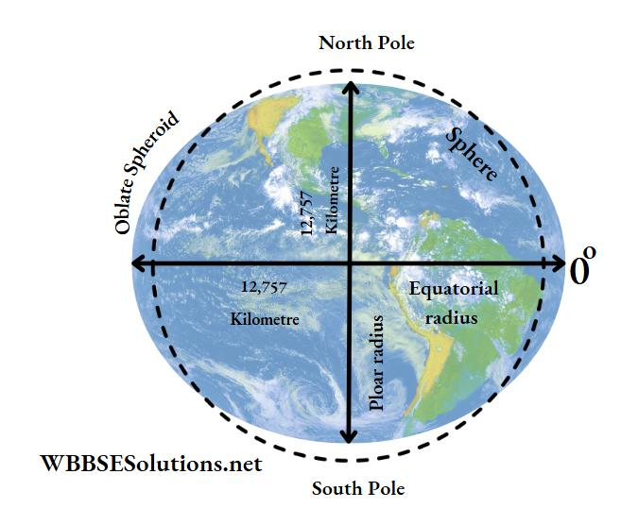
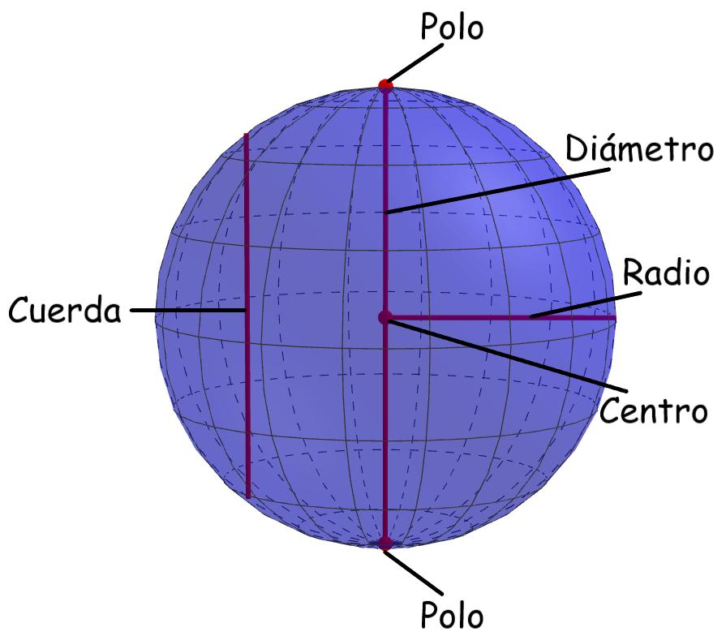

Definition
# Source: AI Source: Provided by: [Data Path: Persons Table -> ID Column: 1, Name_En Column: Motasem Essam] -> From: [ChatGPT] on [7/25/2026]
The polar diameter is the diameter of a sphere or sphere-like body measured along its polar axis, connecting its North Pole and South Pole through its center.
For a perfect sphere, the polar diameter is equal to every other diameter. For an oblate spheroid, such as Earth, the polar diameter is shorter than the equatorial diameter because the body is flattened at its poles.
The polar diameter is twice the polar radius:
$$\boxed{D_{p}=2R_{p}}$$

Simple Definition
# Source: AI Source: Provided by: [Data Path: Persons Table -> ID Column: 1, Name_En Column: Motasem Essam] -> From: [ChatGPT] on [7/25/2026]
The polar diameter is a straight segment running from one pole to the opposite pole through the center of a sphere-like body.
- First endpoint: North Pole.
- Middle point: Center of the body.
- Second endpoint: South Pole.
- Direction: Along the polar axis.
- Length: Twice the polar radius.

Geometric Representation
# Source: AI Source: Provided by: [Data Path: Persons Table -> ID Column: 1, Name_En Column: Motasem Essam] -> From: [ChatGPT] on [7/25/2026]
Let:
- $N$ be the North Pole.
- $S$ be the South Pole.
- $O$ be the center.
- $R_{p}$ be the polar radius.
- $D_{p}$ be the polar diameter.
The points $N$, $O$, and $S$ lie on the same straight line.
$$NO=OS=R_{p}$$
Therefore:
$$D_{p}=NO+OS$$
$$\boxed{D_{p}=2R_{p}}$$
The center $O$ is the midpoint of the polar diameter.

Geometric Cases
# Source: AI Source: Provided by: [Data Path: Persons Table -> ID Column: 1, Name_En Column: Motasem Essam] -> From: [ChatGPT] on [7/25/2026]
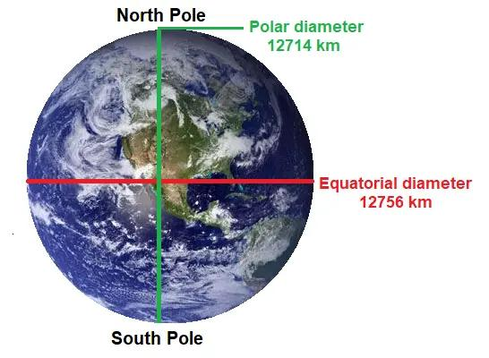

Polar Diameter of a Perfect Sphere
# Source: AI Source: Provided by: [Data Path: Persons Table -> ID Column: 1, Name_En Column: Motasem Essam] -> From: [ChatGPT] on [7/25/2026]
All diameters of a perfect sphere have equal lengths.
$$D_{p}=D=2R$$
The polar diameter equals the equatorial diameter.
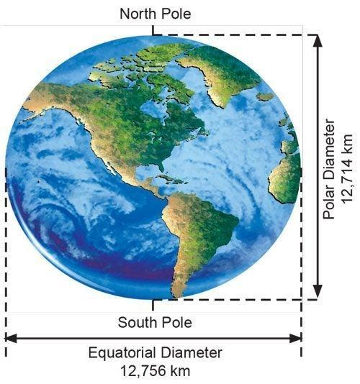

Polar Diameter of an Oblate Spheroid
# Source: AI Source: Provided by: [Data Path: Persons Table -> ID Column: 1, Name_En Column: Motasem Essam] -> From: [ChatGPT] on [7/25/2026]
The body is flattened at its poles.
$$D_{p}<D_{e}$$
The polar diameter is shorter than the equatorial diameter.
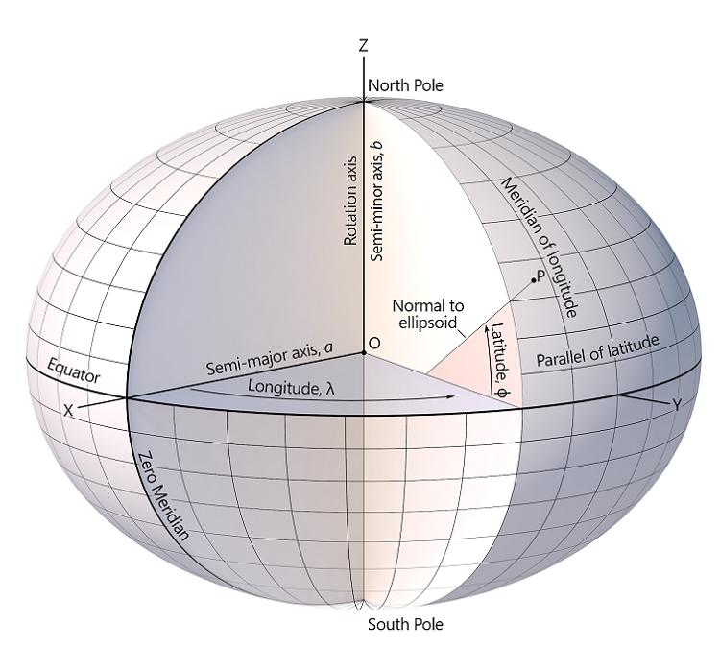

Polar Diameter of a Prolate Spheroid
# Source: AI Source: Provided by: [Data Path: Persons Table -> ID Column: 1, Name_En Column: Motasem Essam] -> From: [ChatGPT] on [7/25/2026]
The body is elongated along its polar axis.
$$D_{p}>D_{e}$$
The polar diameter is longer than the equatorial diameter.
Here, $D_{e}$ denotes the equatorial diameter.

Key Characteristics
# Source: AI Source: Provided by: [Data Path: Persons Table -> ID Column: 1, Name_En Column: Motasem Essam] -> From: [ChatGPT] on [7/25/2026]
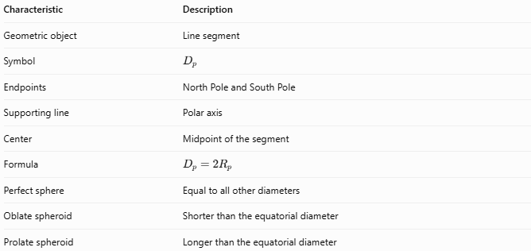
Characteristic | Description
Geometric object | Line segment
Symbol | $$D_{p}$$
Endpoints | North Pole and South Pole
Supporting line | Polar axis
Center | Midpoint of the segment
Formula | $$D_{p}=2R_{p}$$
Perfect sphere | Equal to all other diameters
Oblate spheroid | Shorter than the equatorial diameter
Prolate spheroid | Longer than the equatorial diameter

Mathematical Formulas

Polar Diameter from Polar Radius
# Source: AI Source: Provided by: [Data Path: Persons Table -> ID Column: 1, Name_En Column: Motasem Essam] -> From: [ChatGPT] on [7/25/2026]
$$\boxed{D_{p}=2R_{p}}$$

Polar Radius from Polar Diameter
# Source: AI Source: Provided by: [Data Path: Persons Table -> ID Column: 1, Name_En Column: Motasem Essam] -> From: [ChatGPT] on [7/25/2026]
$$\boxed{R_{p}=\frac{D_{p}}{2}}$$

Polar Flattening
# Source: AI Source: Provided by: [Data Path: Persons Table -> ID Column: 1, Name_En Column: Motasem Essam] -> From: [ChatGPT] on [7/25/2026]
For an oblate spheroid, flattening can be calculated from its polar and equatorial diameters:
$$\boxed{f=\frac{D_{e}-D_{p}}{D_{e}}}$$
This is equivalent to the formula using radii because both diameters are twice their corresponding radii.

Equation of a Spheroid
# Source: AI Source: Provided by: [Data Path: Persons Table -> ID Column: 1, Name_En Column: Motasem Essam] -> From: [ChatGPT] on [7/25/2026]
For a spheroid centered at the origin, with its polar axis along the $z$-axis:
$$\boxed{\frac{x^{2}+y^{2}}{R_{e}^{2}}+\frac{z^{2}}{R_{p}^{2}}=1}$$
The polar diameter is $D_{p}=2R_{p}$, while the equatorial diameter is $D_{e}=2R_{e}$.

Worked Examples
# Source: AI Source: Provided by: [Data Path: Persons Table -> ID Column: 1, Name_En Column: Motasem Essam] -> From: [ChatGPT] on [7/25/2026]
Example 1 — Finding the Polar Diameter
A perfect sphere has a radius of $8\text{ cm}$. Find its polar diameter.
Solution:
$$D_{p}=2R$$
$$D_{p}=2\left(8\right)$$
$$\boxed{D_{p}=16\text{ cm}}$$
Example 2 — Finding the Polar Radius
A sphere-like body has a polar diameter of $12\text{ m}$. Find its polar radius.
Solution:
$$R_{p}=\frac{D_{p}}{2}$$
$$R_{p}=\frac{12}{2}$$
$$\boxed{R_{p}=6\text{ m}}$$
Example 3 — Comparing Polar and Equatorial Diameters
An oblate spheroid has an equatorial diameter of $20\text{ m}$ and a polar diameter of $19\text{ m}$. Find its flattening factor.
Solution:
$$f=\frac{D_{e}-D_{p}}{D_{e}}$$
$$f=\frac{20-19}{20}$$
$$\boxed{f=0.05=5\%}$$
The polar diameter is 5% shorter than the equatorial diameter.

Polar Diameter vs. Equatorial Diameter
# Source: AI Source: Provided by: [Data Path: Persons Table -> ID Column: 1, Name_En Column: Motasem Essam] -> From: [ChatGPT] on [7/25/2026]
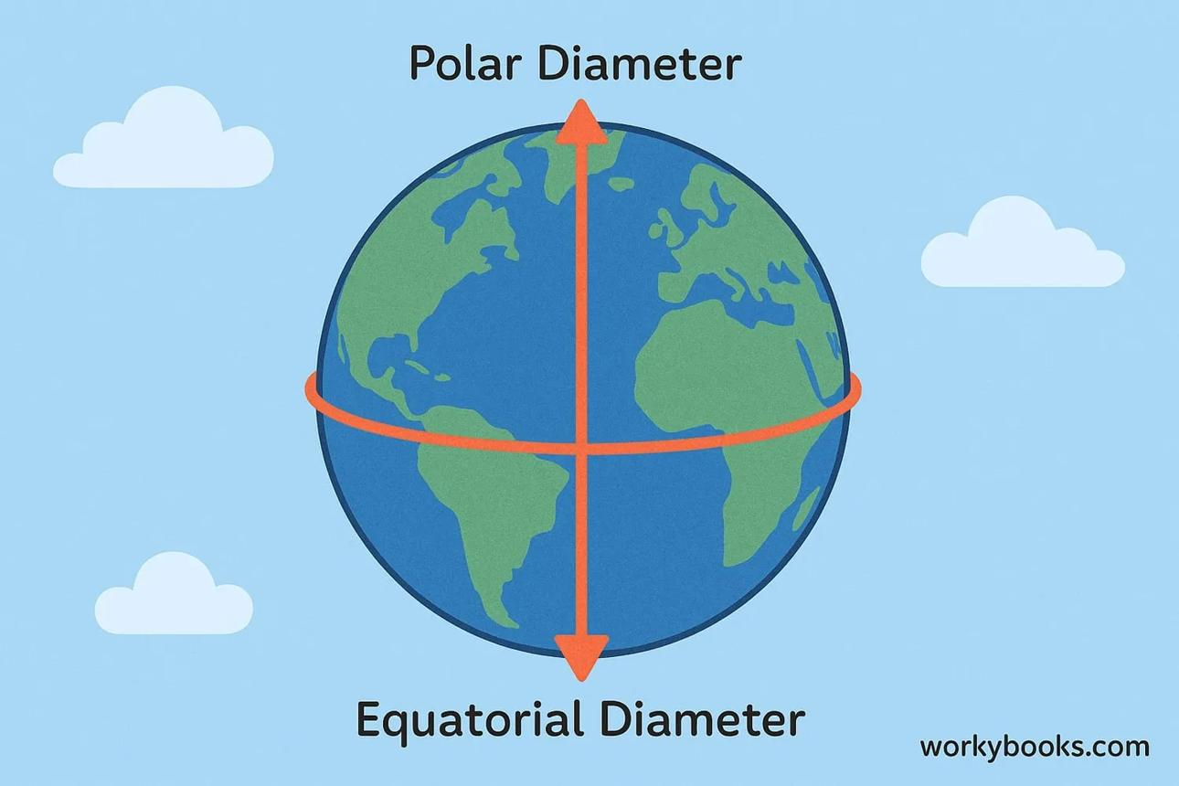
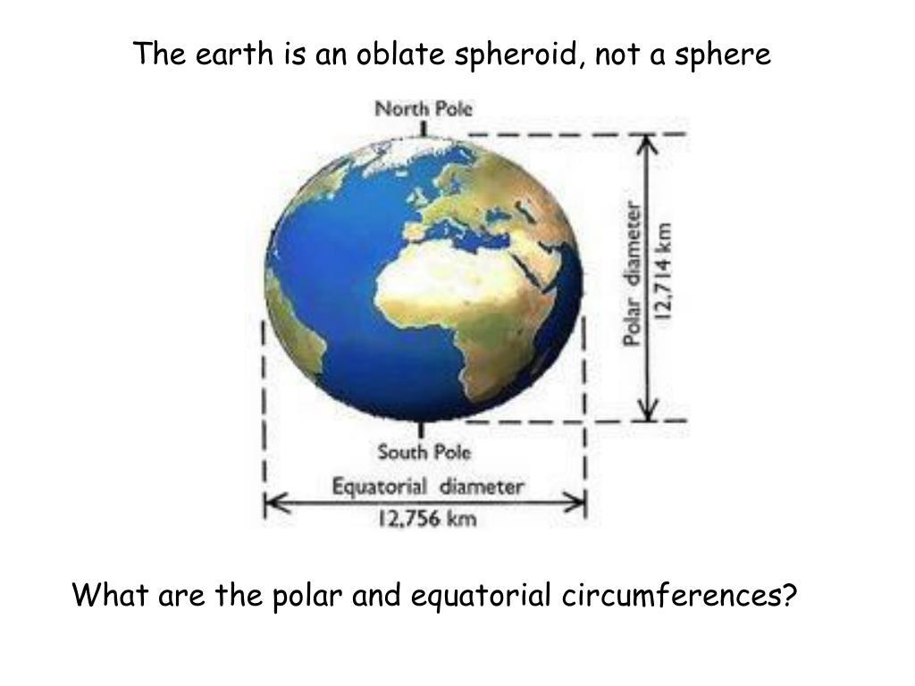
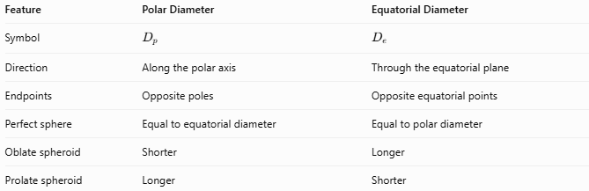
Feature | Polar Diameter | Equatorial Diameter
Symbol | $$D_{p}$$ | $$D_{e}$$
Direction | Along the polar axis | Through the equatorial plane
Endpoints | Opposite poles | Opposite equatorial points
Perfect sphere | Equal to equatorial diameter | Equal to polar diameter
Oblate spheroid | Shorter | Longer
Prolate spheroid | Longer | Shorter

Real-World Application: Earth
# Source: AI Source: Provided by: [Data Path: Persons Table -> ID Column: 1, Name_En Column: Motasem Essam] -> From: [ChatGPT] on [7/25/2026]
Earth is approximately an oblate spheroid. Under the WGS 84 reference ellipsoid:
- Polar radius: approximately $6,356.752\text{ km}$
- Polar diameter: approximately $12,713.505\text{ km}$
- Equatorial diameter: approximately $12,756.274\text{ km}$
The equatorial diameter is approximately $42.769\text{ km}$ greater than the polar diameter. This difference matters in geodesy, cartography, satellite navigation, and precise modeling of Earth's shape.

Key Points
# Source: AI Source: Provided by: [Data Path: Persons Table -> ID Column: 1, Name_En Column: Motasem Essam] -> From: [ChatGPT] on [7/25/2026]
- The polar diameter runs through the center along the polar axis.
- Its endpoints are the North Pole and South Pole.
- It equals twice the polar radius.
- In a perfect sphere, all diameters are equal.
- In an oblate spheroid, the polar diameter is shorter than the equatorial diameter.
- In a prolate spheroid, the polar diameter is longer than the equatorial diameter.

Conclusion
# Source: AI Source: Provided by: [Data Path: Persons Table -> ID Column: 1, Name_En Column: Motasem Essam] -> From: [ChatGPT] on [7/25/2026]
The polar diameter measures the full distance between the two poles through the center of a sphere-like body. It equals the ordinary diameter of a perfect sphere but can differ from the equatorial diameter of a spheroid, making it useful for describing the shape of planets and other rounded bodies.

